**Correlation:**

Correlation is a statistical measure that indicates the extent to which two or more variables fluctuate in relation to each other.

A **Positive Correlation** indicates the extent to which those variables increase or decrease in parallel.

A Negative **Correlation** indicates the extent to which one variable increases as the other decreases.

A **Correlation Coefficient** is a statistical measure, of the degree to which changes to the value of one variable predict change to the value of another. When the fluctuation of one variable reliably predicts a similar fluctuation in another variable, there’s often a tendency to think that means that the change in one causes the change in the other.

**Note:** However, correlation does not imply causation. There may be, for example, an unknown factor that influences both variables similarly. Distinguishing between correlation and causation can be valuable when it comes to consumer data patterns, and provide valuable insights. The beer and diapers example is frequently used to highlight this in the context of marketing.

**Bivariate Data:**

In statistics, **bivariate data** is data on each of two variables, where each value of one of the variables is paired with a value of the other variable.

It is a specific but very common case of multivariate data. The association can be studied via a tabular or graphical display, or via sample statistics which might be used for inference. Typically, it would be of interest to investigate the possible association between the two variables.

 The method used to investigate the association would depend on the level of measurement of the variable. This association that involves exactly two variables can be termed a bivariate correlation, or bivariate association.

**Types of Correlation**

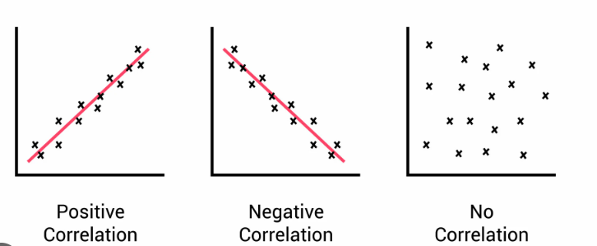

**Positive Correlation:**

The plotted points are clustered around an upward sloping line.

As the values of the one variable increase, the value of the other variable tends to increase as well.

As the values of the one variable decrease, the value of the other variable also decreases.

Direct relationship between two variables.

e.g. Height & weight, Temperature & Ice Cream sales etc.

**Negative Correlation:**

The plotted points are clustered around a downward sloping line.

As the values of the one variable increase, the value of the other variable tends to increase as well.

As the values of the one variable decrease, the value of the other variable also decreases.

Indirect relationship between two variables.

Eg. Price & Demand etc.

**No Correlation:**

There is no linear trend.

There is no linear correlation between two variables.